8 СЛАЙД

USE BSTU;GO
DECLARE @StudentsCount INT;DECLARE @AuditoriumCount INT;DECLARE @TeacherCount INT;
SET @StudentsCount = (SELECT COUNT(*) FROM dbo.STUDENT);SET @AuditoriumCount = (SELECT COUNT(*) FROM dbo.AUDITORIUM);SET @TeacherCount = (SELECT COUNT(*) FROM dbo.TEACHER);
SELECT
AUDITORIUM_TYPE AS [Тип аудитории],
COUNT(*) AS [Количество аудиторий]FROM dbo.AUDITORIUMGROUP BY AUDITORIUM_TYPE;
SELECT
PULPIT AS [Кафедра],
COUNT(*) AS [Количество дисциплин]FROM dbo.SUBJECTGROUP BY PULPIT;
PRINT 'Количество студентов: ' + CAST(@StudentsCount AS VARCHAR(10));PRINT 'Количество аудиторий: ' + CAST(@AuditoriumCount AS VARCHAR(10));PRINT 'Количество преподавателей: ' + CAST(@TeacherCount AS VARCHAR(10));GO

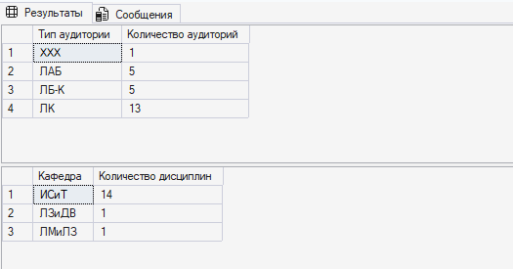

14 СЛАЙД

USE BSTU;GO
DECLARE @y1 NUMERIC(8,3);DECLARE @y2 NUMERIC(8,3);DECLARE @y3 NUMERIC(8,3);DECLARE @y4 NUMERIC(8,3);
SET @y1 =(
SELECT CAST(SUM(AUDITORIUM_CAPACITY) AS NUMERIC(8,3))
FROM dbo.AUDITORIUM);
IF @y1 > 200BEGIN
PRINT 'Общее количество мест больше 200';

SET @y2 = (
SELECT CAST(COUNT(*) AS NUMERIC(8,3))
FROM dbo.AUDITORIUM
);

SET @y3 = (
SELECT CAST(AVG(AUDITORIUM_CAPACITY) AS NUMERIC(8,3))
FROM dbo.AUDITORIUM
);

SET @y4 = (
SELECT CAST(COUNT(*) AS NUMERIC(8,3))
FROM dbo.AUDITORIUM
WHERE AUDITORIUM_CAPACITY > @y3
);

SELECT
@y1 AS [Общая вместимость],
@y2 AS [Количество аудиторий],
@y3 AS [Средняя вместимость],
@y4 AS [Аудиторий выше средней],
@y4 / @y2 * 100 AS [Процент];ENDELSE IF @y1 > 100
PRINT 'Общее количество мест от 100 до 200';ELSE IF @y1 > 50
PRINT 'Общее количество мест от 50 до 100';ELSE
PRINT 'Общее количество мест менее 50';GO

